Family Arts Campaign Evaluation: Case study information

Name: Ellie Jeffs
Job Title: Interim Learning Manager
Organisation: Arnolfini | NPO: YES
Contact: ellie.jeffs@arnolfini.org.uk | Date: 04/11/14

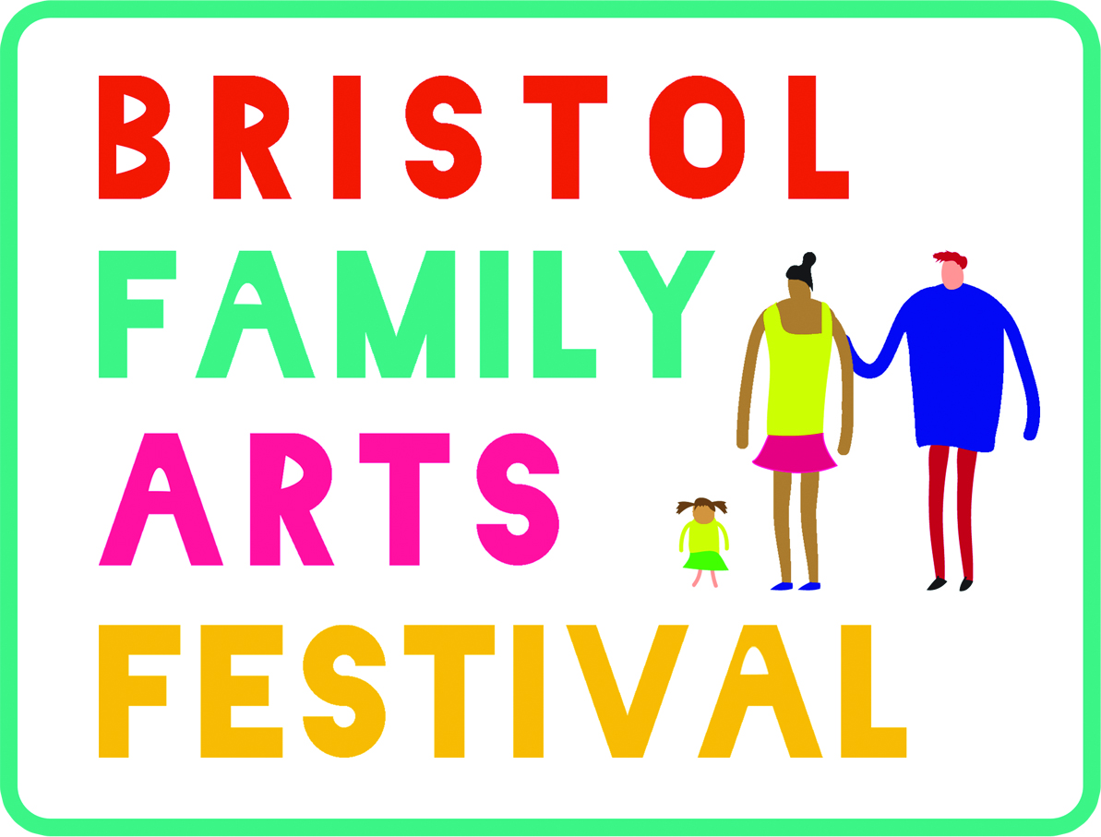
1.What has been your involvement with the Family Arts Campaign to date? (2013/2014)
In early 2013 Arnolfini identified families as a key audience group to develop through consultation, leading to revised activity, programme and facilities for this audience. Arnolfini signed up to be one of 5 organisations to pilot the Quality of Experience Study http://www.vasw.org.uk/about-us/programme/current/quality-of-experience-study.php in partnership with Annabel Jackson Associates and Visual Arts Southwest. Our interest was in finding out about the quality of experience that our family audience currently had and what we could do to improve this. We also became the ‘family strand’ lead for the Bristol Cultural Education Partnership http://bristolculturaleducation.weebly.com/ in order to share our research and findings regarding family audiences with other Bristol organisations. One of the main objectives of the BCEP is to foster collaborative working between Bristol organisations with shared interests.
After attending a Family Arts Festival Conference introducing the Family Arts Campaign, Ellie Jeffs (Interim Learning Manager) fed back to the BCEP group and headed up a steering group to form the Bristol Family Arts Network. The Bristol Family Arts Network is made up of the following organisations: Arnolfini, Bristol Children’s Scrapstore, Bristol Museums, Galleries and Archives, MShed, Watershed, Bristol Hippodrome, Bristol Old Vic, Architecture Centre, Brunel’s ss Great Britain. We began working together to programme festival activity in 2013.
In 2014 we came together again to programme a festival which addressed areas for improvement that we had identified in evaluation of our activity in 2013, including more effective joint marketing, joint delivery of events and an increase in outreach workshops to reach families that had not previously engaged with our festival programme.
Video interview created by Roseanna Dias after Family Arts Festival 2013 about our aims for Family Arts Festival 2013 and wider family programme. https://vimeo.com/85550675
2. Why did you engage with the Family Arts Campaign?
We feel strongly that the arts should be open and accessible to all. At Arnolfini our ‘We Are Family’ programme focusses on activities that families can do together to help them to explore themes from our exhibitions and wider programme. Children who attend these events with their parents/carers will become our audiences for the future and if we can foster an interest in and excitement about the arts at a young age we are more likely to create an audience base who keep coming back throughout their lives. We hope to foster this progression through our schools and young people’s programme also.
In 2010 we carried out an MHM (Morris Hargreaves McIntyre) Interaction Review and discovered the following about our existing audiences:
“Arnolfini is successful in reaching the people who know and love art. They crossover from exhibitions to live art to film. The arts are essential to their lives. They see the Arnolfini as a close and trusted friend; a reflection of their cultural tastes. They are creative, young and intelligent. They often work or study in the arts and are fiercely independent minded. The majority are experts and third spacers.”
Family audiences made up just 9% of our overall audiences. By analyzing both family and other audience types we found that those not accessing Arnolfini are those who are less likely to take a risk and need more reassurance, support and perhaps a more tailored or bespoke offer.
Our research through the Quality of Experience Study (mentioned in previous section) helped us to quantify and identify in more detail what was lacking from our current family provision and what changes we could make to attract more families to engage with Arnolfini.
On the basis of these two research studies and through sharing of ideas with other local organisations, the Family Arts Campaign and Family Arts Festival seemed like a useful addition to our regular family activities and a catalyst for collaborative family work throughout the city, creating a joint family offer and encouraging more families to use arts, heritage and cultural organisations in Bristol.
3. What did you produce for FAF 2014?

The Bristol Family Arts Network put on at least 48 separate events as part of the festival this year. Arnolfini produced the following events (many working with partners). We wanted a mixture of outreach events and those held in our building to appeal to different audiences and to engage hard to reach audiences. We worked with a variety of partner organisations from the Bristol Family Arts Network as well as new community based partners, in Easton, Lawrence Weston, Hartcliffe, Redcliffe and Knowle West, who we hope to continue to work with in the lead up to next year’s festival.

18/10/14
Junction 3 Library, Easton (Architecture Centre, Scrapstore & Arnolfini)
Drop-in creative workshop
1-4pm, FREE

21/10/14
Arnolfini
Exhibition Buggy Tour
11:30 FREE

Arnolfini
Storytelling
10:30am FREE

25/10/14
Arnolfini
Family Film Screening
11am-1pm FREE

Arnolfini
We Are Family- creative workshop
1pm-5pm FREE

Lawrence Weston Community Farm (Architecture Centre, Scrapstore and Arnolfini)
Drop-in creative workshop
1-4pm, FREE

Arnolfini (Arnolfini, National Trust and Scrapstore)
Mud Play event at Leigh Woods
10am-5pm, FREE

26/10/14
Arnolfini (Arnolfini, National Trust and Scrapstore)
Mud Play event at Leigh Woods
10am-5pm, FREE

28/10/14
Arnolfini
Storytelling
10:30am FREE

29/10/14
Arnolfini
Family Film Screening
11am-1pm FREE

Hartcliffe- Room 13 (Architecture Centre, Scrapstore and Arnolfini)
Drop-in creative workshop
1-4pm, FREE

30/10/14
Arnolfini
Family Film Screening
11am-1pm FREE

Knowle West Media Centre (Architecture Centre, Scrapstore and Arnolfini)
Drop-in creative workshop
11-3pm, FREE

31/10/14
Arnolfini
Family Film Screening
11am-1pm FREE

01/11/14
Arnolfini (Architecture Centre, Scrapstore, Playing Out, Watershed and Arnolfini)
The Big Family Arts Picnic
12pm-4pm, FREE

Although less successful in terms of attendance numbers, we had a very good response and audience feedback from outreach events. Visitor surveys showed that families in these areas felt there was little family provision for them currently but it was great that activity was being brought out of the city centre to their local community.
Through visitor surveys and postcode collection at our Family Arts Festival events held at Arnolfini, we can see that the majority of visitors came from the following areas in Bristol.
- 25%- BS3 (Bedminster and Southville)
- 11%- BS7 (Bishopston and Horfield)
- 9%- BS4 (Knowle West)
- 8%- BS5 (Easton)
- 8% BS16 (Fishponds and Frenchay)
When compared to our postcode data collected from our regular family ‘We Are Family’ events programme, between Jan ’14 to September ’14 it is clear that the outreach workshops did have a small but significant impact on our audience base.
- 15%- BS3 (Bedminster and Southville)
- 13%- BS7 (Bishopston and Horfield)
- 9%- BS6 (Redland)
- 8%- BS8 (Clifton)
- 7%- BS5 (Easton)
- 6%- BS4 (Knowle West)
One increase came from our BS5 based audience which is where we also held an outreach event last year. There is anecdotal evidence that a significant portion (approx. 30%) of attendees came to the outreach event here in 2013 also and therefore looked for the event as part of the Family Arts Festival programme for this year. We also noticed a surprising rise in attendees from Fishponds which is another area that we had previously identified as a hard to reach community but not one that we had targeted this time through outreach activity.
(See Appendix 1 for details)
4. Why join a network?
We have found it really beneficial being part of a Family Arts Festival network. The Bristol Family Arts Network group meets about 4 times a year to discuss programme plans for the festival, our aims, and how we will evaluate our successes. One of the main aims that we identified early on was the need for a joint offer for families in the city and a central place for information, to make this offer easily accessible. By working together to share ideas, promote one another’s events and collaborate on programme we are now providing a really exciting offer for families. Some of the partnerships have become so strong that they have continued outside of the Family Arts Festival period. For example we are collaborating with Architecture Centre (our neighbours) on more projects with schools and Bristol Children’s Scrapstore have become regular supporters of our We Are Family programme.
There are already at least 5 other organisations in Bristol that are keen to join the Bristol Family Arts Festival network and include their family activities in the 2015 FAF programme. The decision for next year is going to be around how to keep the network a manageable size and whether we can bring in additional funding for someone to take on administration for the festival as this is a capacity heavy task.

- Please tell what you did for FAC 2013 and 2014
New product; a shift in your overall approach to family audience engagement, a new activity to build audiences for a particular event, a ‘quick fix’ or an improvement in a particular area of marketing.
For the Family Arts Festival this year, our main aim was to bring in new audiences and in particular participants from our identified outreach areas. We wanted our outreach and other events to build to a culminative event, The Big Family Arts Picnic, which would be a celebration of the Bristol Family Arts Festival and which we could invite participants from our outreach workshops to come along to. Our original plan was to work with local transport companies to put on transport for families in our target communities to allow them to attend this event, but sadly this was not successful this year. We will be trying this approach again next year as transport costs have been identified as a very real barrier to families from these communities. We also wanted to work together as a network on more jointly developed and delivered events.
Our other aim was to provide effective joint marketing in order to spread the message as widely as possible. We produced and distributed 25,000 leaflets which went out to children’s centres, libraries, tourist information, nurseries and primary schools. We put our marketing teams in contact with one another and promoted each other’s events. We were also featured in local media including Jack FM, Bristol Post, Mail on Sunday, Visit Bristol. Please see links below and attached documents for examples of press/media coverage.
http://www.artscouncil.org.uk/news/arts-council-news/fun-all-family-arts-festival-south-west-october/
http://visitbristol.co.uk/things-to-do/bristol-family-arts-festival-p1738993
http://bridge.realideas.org/latest-news/news-articles/396-bristol-family-arts-festival#.VIh1QTGsWd4
https://www.ents24.com/bristol-events/ss-great-britain/bristols-family-arts-festival-the-big-family-arts-picnic/3967858
http://www.freelancemum.co.uk/podcast/bristol-family-arts-trail/

We worked hard on social media to cross promote activity and drive our online visitors towards our organisations websites:
https://storify.com/Arnolfiniarts/family-arts-festival
Overall total - Family + FAF specific content - 3,848 unique users
Arnolfni family pages since FAF has been uploaded - 1,227 unique users

Looking at the data we collected from visitor surveys it appears that a significant percentage of people had received the Bristol Family Arts Festival leaflet this year.
25% of our surveyed visitors had found out about the festival through our leaflet, that’s an increase of almost 13% when compared to last year.
The largest proportion however (40%) still find out about the festival through friends and ‘word of mouth’. This is an interesting finding as it helps us to understand how important family advocates and tapping into local family networks could be. This is one of our main areas for improvement next year, with the aim to cultivate a relationship with local family bloggers, parents groups and online parents’ networks (of which there are many in Bristol). Arnolfini already has a relationship with Bristol Mum, as do other Bristol FAF network partners http://bristolmum.com/2014/04/22/we-are-family-afternoons-regular-free-activities-at-bristols-arnolfini/ but it would be really valuable to reach out the other parent bloggers in the city.

6. Did you identify any change you wanted to make with regard to your family offer as a result of Family Arts Campaign? Were there any ‘eureka’ moments?
● There are many advantages to working with partners on family events and we will definitely be doing more of this in the future. Over the past year (since the 2013 Family Arts Festival) Arnolfini has teamed up with Bristol Children’s Scrapstore to deliver 5 of our We Are Family events. The advantages of doing this is are that we can promote to both our existing family networks, share resources and capacity when it comes to the event itself, think of fresh approaches and activities, share marketing responsibility. We have also started to collaborate on our work with schools with Architecture Centre (Heritage schools programme) and have plans to also work with Bristol Old Vic on collaborative work with schools and families in the near future. We would like to see this replicated across the other network partners.
● More outreach workshops are essential if we want to continue to grow our family audience and ensure that our offer is as open and accessible as possible. Now that we have partners based in target communities, this work will certainly continue. We also have big plans around our offsite public artworks for summer 2015, again meaning that we’ll be working visibly out in the community.
● Building on the success of the established Parents 4 Play network, coordinated by Bristol Children’s Scrapstore, and due to obvious interest from families in wanting to sign up to our mailing list (45 new contacts), we will explore options for a quarterly e-newsletter highlighting family activities hosted by Bristol FAF network partners. We are also looking at creating a website or holding page for the Bristol Family Arts Festival next year to provide a clear and useful place for families to find out more about the festival and events that are on offer.

- What impact do you want your new activity or way of working to have on the size or profile of your family audience/visitor base?
AIMS OF BRISTOL FAF NETWORK
• Diversifying audiences
• Increasing numbers of ‘family’ visitors
• Increased impact and reach by working collaboratively with neighbouring arts/cultural organisations- smaller organisations supported by larger organisations.
• Peer learning and support amongst arts/cultural/participation/learning colleagues from partner organisations.
• Support Arts Award offers (as many of these organisations offer Arts Award)
• A shift in perception by the general public to see that the harbourside cultural organisations are places that are open and welcoming for families/everyone.
• Long-term, inter-institutional projects, resulting in a more collaborative practice across the city and leading to enhancing and enriching the experiences of family audiences across artforms.

- What tools are you using to measure this impact?
For example box office data; audience/visitor survey; Google Analytics; social media data
●Visitor surveys with a sample of participants at each event
●Postcode collection from everyone who attends our events (through photo consent forms)
●Box office data re numbers of tickets sold or attendees at each event
●Social media:
https://storify.com/Arnolfiniarts/family-arts-festival
●Collection of comments from visitors and other anecdotal information
●Photographic documentation of all events

- What key indicator are you using to measure progress?

●We are looking at numbers of visitors. We had 862 people attend a Family Arts Festival event at Arnolfini this year. Last year’s figure for Arnolfini FAF events was 664.
2264 people attended a Bristol Family Arts Festival event in 2013. Final figures for this year are still being collated but we expect to see a significant increase.
● Looking at the way that visitors find out about our events, to see how successful our marketing has been:

25% Bristol Family Arts Festival leaflet
40% Word of mouth
18% Venue/organisation website

● % of audiences from target postcodes. See appendix 1 for this information.

- What impact do you expect your new activity or way of working to have on your organisation’s financial position?
All our family events are free of charge (donations only) so we do not expect this to have a direct impact on our finances. However, the data and comments that we have collected over the course of the festival will be incredibly useful for future funding applications (both for our We Are Family programme and the Bristol Family Arts Festival) and to argue the case for more family activity to take place within our programmes.
- How will you measure any revenue generated or savings made?
N/A
- What other objectives are you hoping to achieve?
See aims of Bristol FAF network (question 7)
How have resources provided by FAC supported your activity
●FAC highlights the fantastic work that goes on with families all over the country. Locally the festival is a way to showcase each individual organisation’s offer and show families that they are a really important and valued audience.
●It is useful to have the support of FAC when trying in implement change/programme for families within organisations stats and evidence to prove what we’re campaigning for.
●Training and meetings with other FAF networks have been useful, as it’s really helpful to hear about other’s approach to the festival and how their networks operate.
More toolkits and training would be good for next year and the website urgently needs reviewing as lots of families mentioned that they found it really confusing to use.

●We have adjusted the FAC branding for our own use. The logo features on all the print that we produced this year but we felt that it was necessary to create our own local brand as this has more resonance with our audiences. Families said that our leaflet was clear, fun, eye-catching and ‘did what it said on the tin’. We do need to review the size of font for next year though to make it more accessible.

●The FAC branding ties us to the national offer and I think this is useful to badge up events and show that it’s a nationally recognised scheme.

●Through the national offer (and FAC website) we’re more likely to attract audiences from outside of Bristol. People seem to be realising that this is an annual offer and certainly recognised the branding from last year’s events, but this will take time to grow.

What have been the most important things you have learned and what will you do differently next time?
● We need a larger type face on our leaflet to make it more accessible.
● More interaction/incentives for family bloggers to get free promotion and advocacy for our offer.
● For the past 2 years we have offered an incentive/prizes to families who attend multiple events, we thought that this would steer families to several venues but in reality this does not seem to be the case. On average 60% of our visitors attend one event and only 35% attend 2-3 events. Next year we are looking to more cleverly programme and stagger our events so that families can attend multiple events on one day. For example spending the morning at Arnolfini, having lunch and activities at Watershed, then visiting MShed in the afternoon. We will also provide a map showing exactly where each organisation is located as they will be more spread out next year with additional network partners coming on board. To help to encourage movement between venues we will also provide an activity trail or something for families to complete as they move from one place to another.
● Better negotiation with transport companies and community transport schemes regarding free/discounted travel for outreach workshop participants.
● Arrange a joint press call (budget/time prevented this)
● More fundraising to pay for someone to support administration of the festival

What ‘tips’ about engaging family audiences would you pass on to other organisations?
● Talk to families about what they want from your festival offer and generally from your organisation. Consultation means that you create the best offer possible.
● Create events that offer families the chance to try something new or something that they can’t do at home- for example large scale, using unusual material and techniques, working with ‘real artists’.
● Make sure events are well signposted outside and within your venue, families are put off if they can’t obviously see where they should go and what they should be doing- make it as easy and straightforward as possible.
● Enthusiastic and friendly staff/volunteers make an event, and help families to feel really valued and welcome.

APPENDIX 1
FAF postcode collection results (October 2014)
We Are Family postcode collection results (Jan 2014-September 2014)

